ST10458688
Nkoka Mashaba ST10458688 CMCSPrototype
Contract Monthly Claim System (CMCS) – Prototype (POE FINAL)

Table of Contents
1. Introduction (Background & Objectives)
........................................................................... 1
2. Design Documentation
..................................................................................................... 2
Design Choices and GUI Layout .......................................................................................... 2
Data Model and Database Structure ..................................................................................... 2
Assumptions and Constraints ............................................................................................... 2
Project Plan Overview ......................................................................................................... 2
Conclusion ........................................................................................................................... 2
3. UML Class Diagram (Database Model) ...........................................................................
Entities and Attributes .......................................................................................................... 3
Relationships ........................................................................................................................ 3
Diagram ................................................................................................................................ 3
Explanation .......................................................................................................................... 3
4. Project Plan......................................................................................................................... 4
5 GUI Screenshots (Prototype Evidence)........................................................................... 5
Dashboard ............................................................................................................................ 5
Submit Claim form ............................................................................................................... 5
Verify Claims (table with Approve buttons) ......................................................................... 5
Track Claims ........................................................................................................................ 5
Login & Register .................................................................................................................. 5
6. Version Control Evidence (GitHub) ................................................................................. 6
7. Conclusion ........................................................................................................................ 7
8.Reference list........................................................................................................................ 8
9.Part 2........................................................................................................................ 8

1. Introduction (Background & Objectives)
The Contract Monthly Claim System, or CMCS for short, that's this prototype web app they put together. It came out of the Portfolio of Evidence, you know, for the PROG6212 module. Basically, the whole idea behind it is to make submitting those monthly claims easier for independent contractor lecturers. Like, verifying and approving them without all the hassle. In real life, this stuff pulls in a bunch of people, lecturers themselves, program coordinators, academic managers too. And it needs checking hours worked, rates, all that supporting paperwork carefully.

This POE thing aims to show off some grasp on C# GUI stuff in the .NET Core setup. Applying what you learn in theory to something actual. Right now, it's just a non-functional prototype. Focuses on design, layout, how the flow goes. Not the back-end or database yet. Still, it gives a good sense of how it'd run for real. Makes sure the UI feels intuitive, user-friendly and all. The scope of Part 1 of the POE includes:
- Planning and documentation, including design explanations, assumptions, and constraints.
- A UML class diagram that models the database structure for claims, users, and supporting documents.
- A project plan outlining the tasks, dependencies, and timeline for prototype development.
- A graphical user interface (GUI) prototype, developed in ASP.NET Core MVC, which demonstrates the key system workflows: claim submission by lecturers, verification by programme coordinators, approval by academic managers, and the ability to track claim status transparently.
Finishing up this first stage, you know, it sets things up nicely for the rest of the POE. Later on, we'll get into adding those functional features, hooking up the database, and putting in the authentication stuff. I mean, the main thing right now is just making sure the design is clear and documented pretty well. That way, the whole final system ends up being efficient, focused on the users, and it lines up with how the academic claim management process is supposed to go.

2. Design Documentation
The Contract Monthly Claim System, or CMCS prototype, gets its design from wanting a simple setup, something intuitive, and role-based for handling lecturer claims. Right now, the thing is non-functional on purpose. It just shows the visual side and structure to give a feel for the user experience. That way, before adding real functionality in later phases, everything looks right.

Design choices and the GUI layout
They built the app with ASP.NET Core MVC. Picked it because it keeps concerns separate, scales well, and fits web-based stuff nicely. There's a shared layout file, _Layout.cshtml, that keeps navigation, branding, and page structure the same everywhere. The top nav bar lets you jump quick to the dashboard, submitting claims, verifying them, approving, tracking, and account things like login or registration.

The dashboard is the landing spot.
Users see their role there, like Lecturer, Programme Coordinator, or Academic Manager. Then they get to their functions. Lecturers have a form to submit claims. It grabs the claim month, hours worked, hourly rate, and a spot for supporting docs, even if it's just a placeholder now. Over on verification, claims show up in a table. Programme coordinators check details and approve. Academic managers use the same setup for final sign-off. Tracking page lets lecturers see status on their claims. Gives transparency all through the workflow, you know.

Data model and database structure.
Prototype has one Claim model for now. It includes stuff like Id, LecturerName, ClaimMonth, HoursWorked, HourlyRate, Status, and SupportingDocument. That's the basics needed to process a claim.

Later, in the full thing, this maps to a Claims table in the database. They'll add Users for lecturers and admins with roles, SupportingDocuments for metadata and file paths on uploads, and ClaimStatusHistory to track changes and audit. The UML class diagram in the report shows all that and how they connect.

Assumptions and constraints.
Made a few assumptions here. User authentication and roles aren't in yet. They'll come later. Supporting docs are just a text field sim, not real file storage. Approvals are fake actions with banner messages, no actual database changes.

Constraints mean focusing only on front-end for this part one. No back-end persistence or integration. Lets them zero in on usability, layout, and those role-based flows.

Project plan overview.
Spread the prototype over three weeks. First week, gathered requirements, drafted UML, built the MVC skeleton. Second week, did the dashboard, claims views, added sample data. Last week, refined UI, wrote docs, prepped submission stuff like the diagram, plan, and report. Kept version control with at least five GitHub commits. Each had good messages.

This design stage sets up a solid base for what's next. Clear GUI, data model, roadmap all in place. The CMCS prototype shows the claim workflow structured and user-friendly. When they add functions later, it should hit technical and usability marks just fine.

3. UML Class Diagram (Database Model)
The database design for the Contract Monthly Claim System (CMCS) is represented using a UML class diagram, which models the core entities, their attributes, and relationships. This diagram provides a blueprint for how data will be structured and stored once database functionality is introduced in later stages of the project.
Entities and Attributes
- User (Lecturer/Staff): Represents individuals who interact with the system. Key attributes include UserId, Username, Password, FullName, and Role. Roles are defined as Lecturer, Programme Coordinator, or Academic Manager, each with specific permissions.
- Claim: Stores claim details submitted by lecturers. Attributes include ClaimId, LecturerId (foreign key to User), ClaimMonth, HoursWorked, HourlyRate, Status, and SupportingDocId.
- SupportingDocument: Stores metadata about uploaded files, such as DocId, FileName, and FilePath. Each claim may have one or more associated supporting documents.
- ClaimStatusHistory: Records the history of status changes for each claim. Attributes include HistoryId, ClaimId, Status, ChangedBy, and ChangedAt. This ensures an audit trail is maintained.
Relationships
- A User can submit multiple Claims, but each claim is linked to only one user.
- A Claim may reference zero or more SupportingDocuments, depending on whether evidence is required.
- A Claim can multiple entries in the ClaimStatusHistory, reflecting its progression through the workflow (e.g., Pending → Verified → Approved).
Diagram
Figure 1: UML Class Diagram for CMCS Database Schema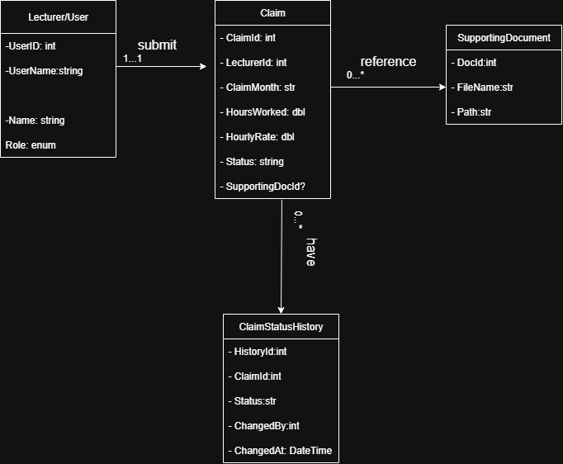
Explanation
The diagram shows how the database is put together logically. It makes sure claims get tracked and handled pretty well. You know, by splitting things into users, claims, documents, and history. That setup keeps data solid, lets you audit everything, and scales up without too much hassle. Like, take the ClaimStatusHistory entity. It records every single action on a claim. Gives you that transparency thing. And oh, separating supporting documents into their own spot stops all the duplication. Makes file management way simpler, basically.

This whole structure ties right into the MVC prototype we have going. The Claim class in the current setup matches up with the Claims entity from the diagram. Then, we'll bring in more stuff like User and SupportingDocument entities down the line. You know, in those later phases of development. To get the prototype matching a real back-end that actually works fully.
4. Project Plan
The project plan for the Contract Monthly Claim System (CMCS) prototype was structured over a three-week period to cover design, development, documentation, and submission requirements. Tasks were broken down into manageable units, with dependencies identified to ensure logical progression.

Week | Task | Dependencies | Duration
Week 1 | Gather requirements and identify assumptions | – | 1 day
Week 1 | Draft UML class diagram (initial design) | Requirements identified | 1 day
Week 1 | Create MVC project skeleton and layout page | – | 2 days
Week 2 | Implement Dashboard, Submit, Verify, and Track views | Layout completed | 3 days
Week 2 | Define Claim model and seed sample data | UML draft completed | 2 days
Week 2 | Apply CSS styling and ensure responsive layout | Core views in place | 2 days
Week 3 | Finalise UML diagram and refine design documentation | Prototype complete | 2 days
Week 3 | Prepare project plan and report (Word document) | Documentation drafted | 2 days
Week 3 | Push at least 5 commits to GitHub with descriptive messages | Development tasks completed | 1 day

5. GUI Screenshots (Prototype Evidence)
Dashboard
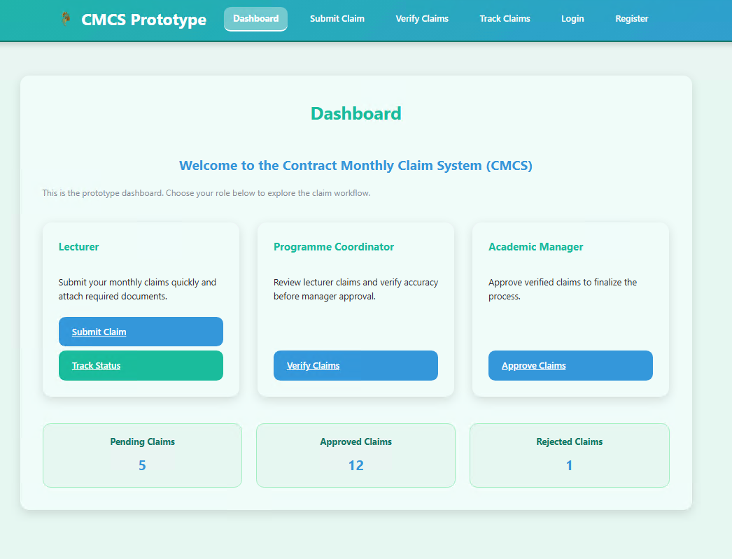

Submit Claim
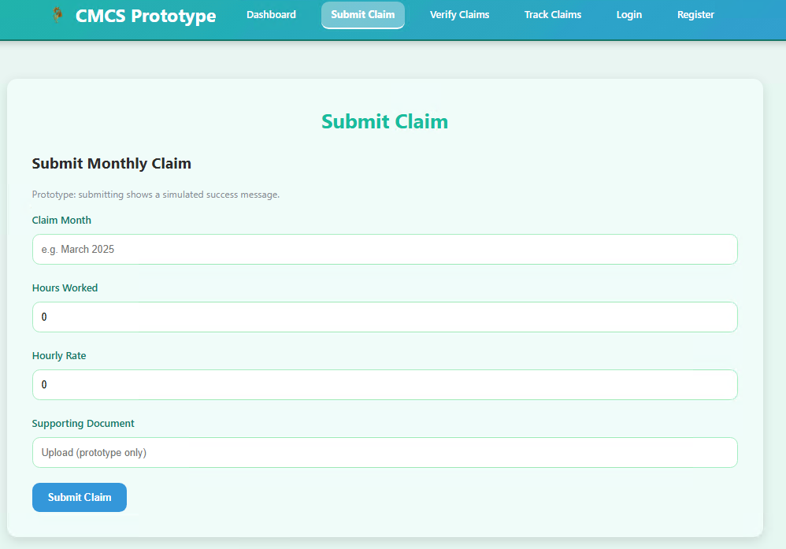

Verify Claims (table with Approve buttons)
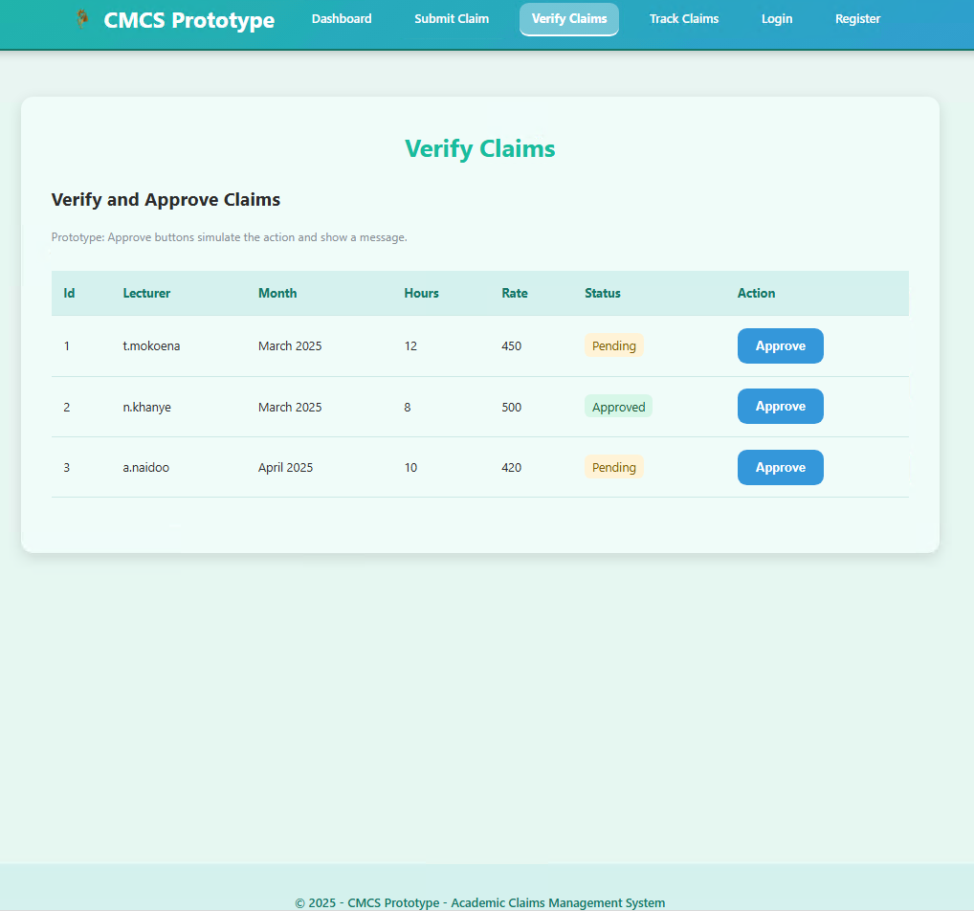

Track Claims
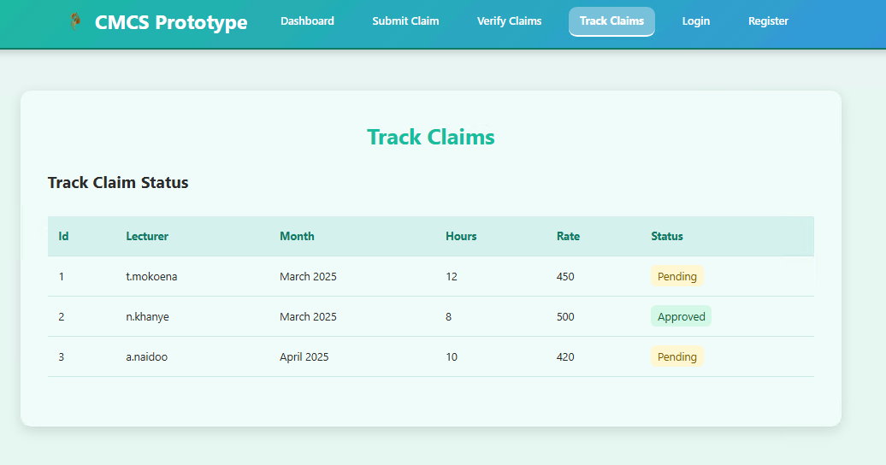

Login
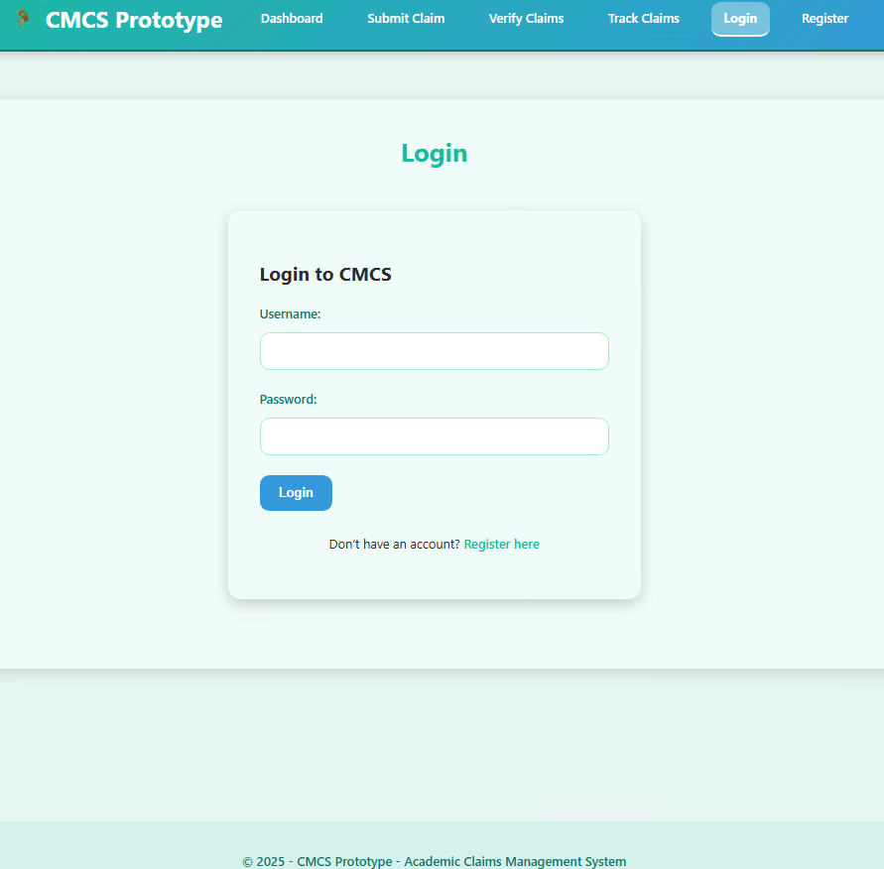

Register
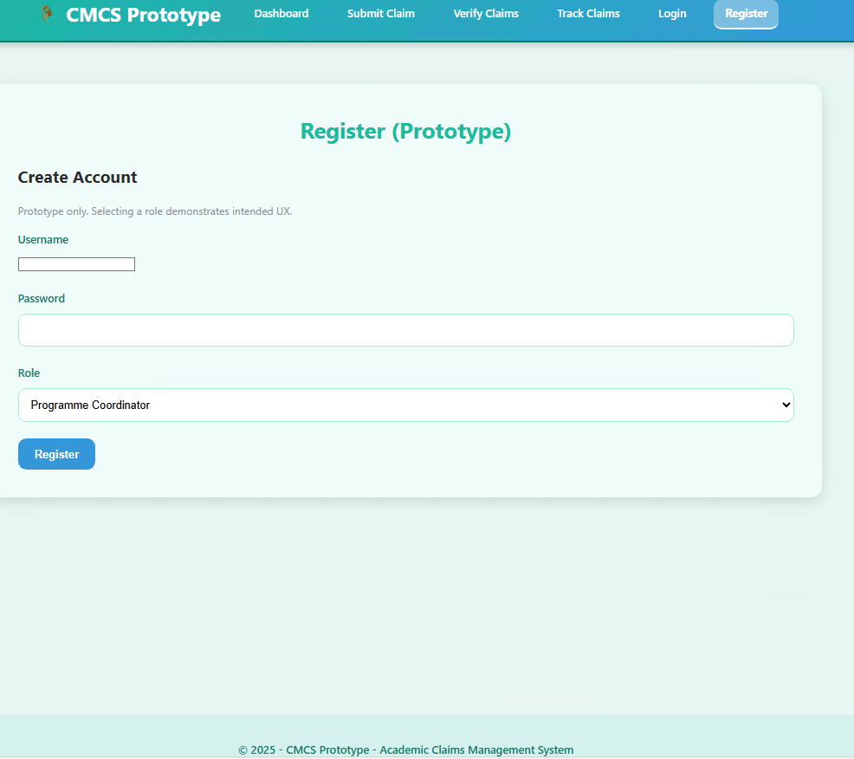

6. Version Control Evidence (GitHub)
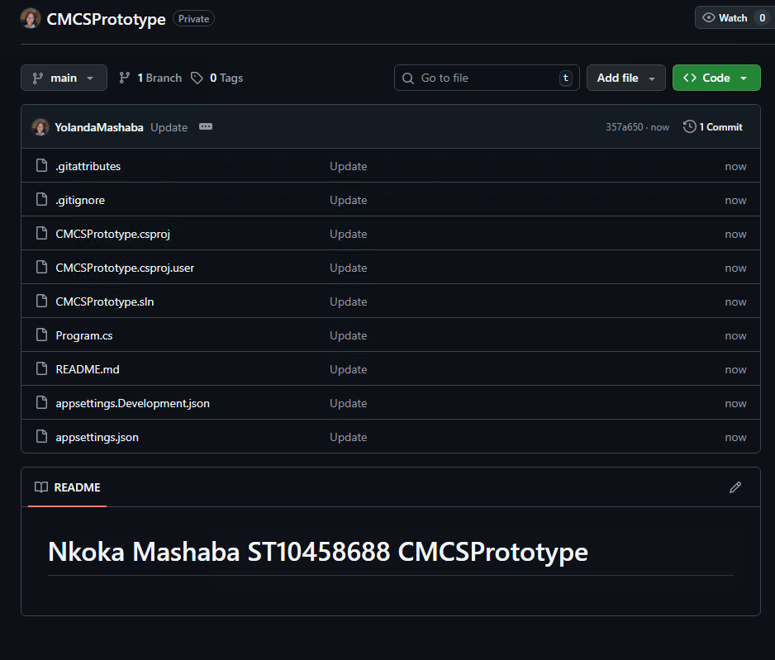

7. Conclusion
The Contract Monthly Claim System prototype for Part 1 of the Portfolio of Evidence. It shows off the planning and design stuff, plus the front-end setup for what the app is supposed to do. We've covered all the deliverables here, like documenting why we made certain choices, putting together a UML class diagram for the database layout, sketching out a project plan, and even building a basic GUI prototype using ASP.NET Core MVC.

This thing walks through the workflows pretty much as planned. Lecturers get to submit their claims, coordinators check them over, and managers approve or turn them down. Oh and there's a tracking spot so lecturers can see what's happening with their stuff the whole way. Right now it's not really working, you know, with fake approvals and dummy uploads for documents, and no real database saving anything. Still, it sets up the basics for when we add the real functions in Part 2.

Usability and clear navigation based on roles. That's what we've focused on a lot. The UML and the plan keep everything pointed in a solid technical way, with a schedule that makes sense. We've stuck to version control too, bunch of commits on GitHub showing how it built up step by step.

Design and planning done now. So the project's ready for Part 2, where we'll add the back-end bits, login stuff, saving data for real, and handling files properly. That phase turns this into something that actually works, lining up with the goal of making claims and approvals easier for lecturers.

8 Reference list
Draw.io (2024). Flowchart Maker & Online Diagram Software. [online] app.diagrams.net. Available at: https://app.diagrams.net.
Freeman, A. (2013). Pro ASP.NET MVC 5. Berkeley, Ca Apress.
Ramotion (2023). MVC Web App Architecture | Ramotion Agency. [online] Web Design, UI/UX, Branding, and App Development Blog. Available at: https://www.ramotion.com/blog/mvc-architecture-in-web-application.
Smith, S. (2024). Overview of ASP.NET Core MVC. [online] Microsoft.com. Available at: https://learn.microsoft.com/en-us/aspnet/core/mvc/overview?view=aspnetcore-9.0.
Tutorialsteacher (2025). ASP.NET MVC Tutorials. [online] www.tutorialsteacher.com. Available at: https://www.tutorialsteacher.com/mvc.

Part 2 – Implementation Update
Part 2 of the Contract Monthly Claim System (CMCS) project represents the transition from a conceptual, non-functional prototype to a working web-based application. While Part 1 focused primarily on planning, design documentation, and interface layout, Part 2 extends that foundation by implementing full functionality within the ASP.NET Core MVC framework. 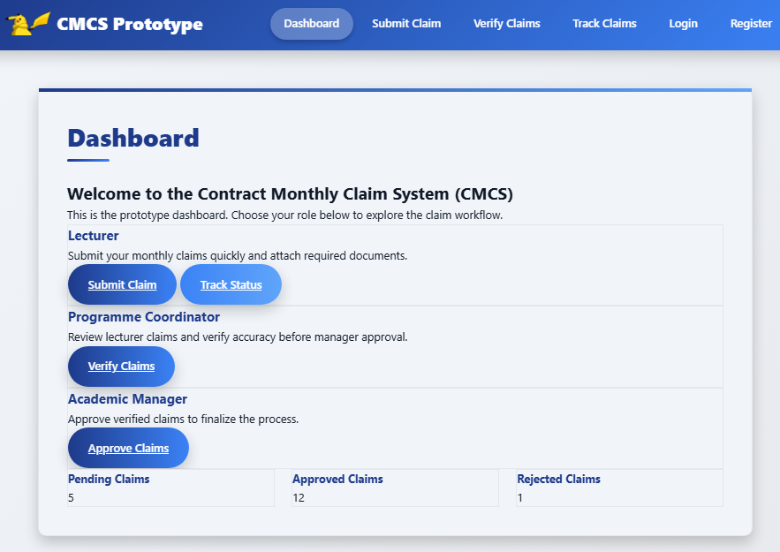
In Part 1, the emphasis was on visual design and system structure. The prototype consisted of static pages that demonstrated user flow but did not process real data. The UML class diagram, project plan, and GUI mock-ups were used to illustrate how lecturers, programme coordinators, and academic managers would interact with the system once functional. No data storage, file management, or logical operations were included at that stage.

Part 2 builds directly on that foundation by introducing interactive and functional components. The claim submission process is now fully implemented, allowing lecturers to complete a form with hours worked, hourly rate, and supporting notes, and to submit their claims at the click of a button. Unlike in Part 1, this submission now performs real input validation and automatically assigns a claim ID and default status.
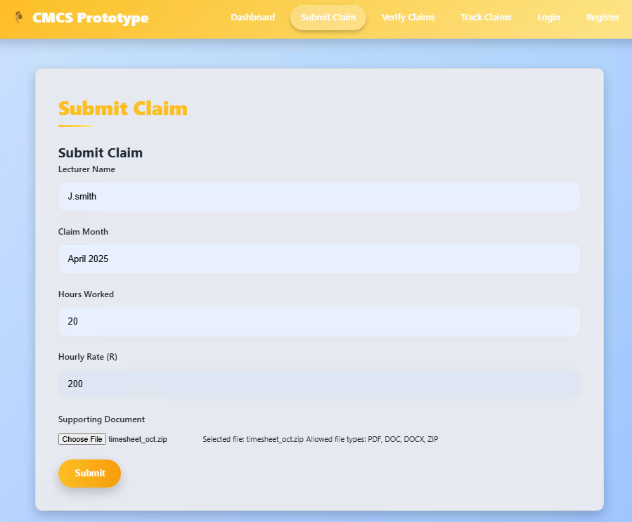
Another major enhancement is the supporting document upload feature. Lecturers can upload evidence in accepted formats such as PDF, DOCX, and XLSX. Uploaded files are stored securely in the application’s wwwroot/uploads directory and linked to their corresponding claims. File handling includes basic validation for size and type, ensuring the system remains secure and stable.
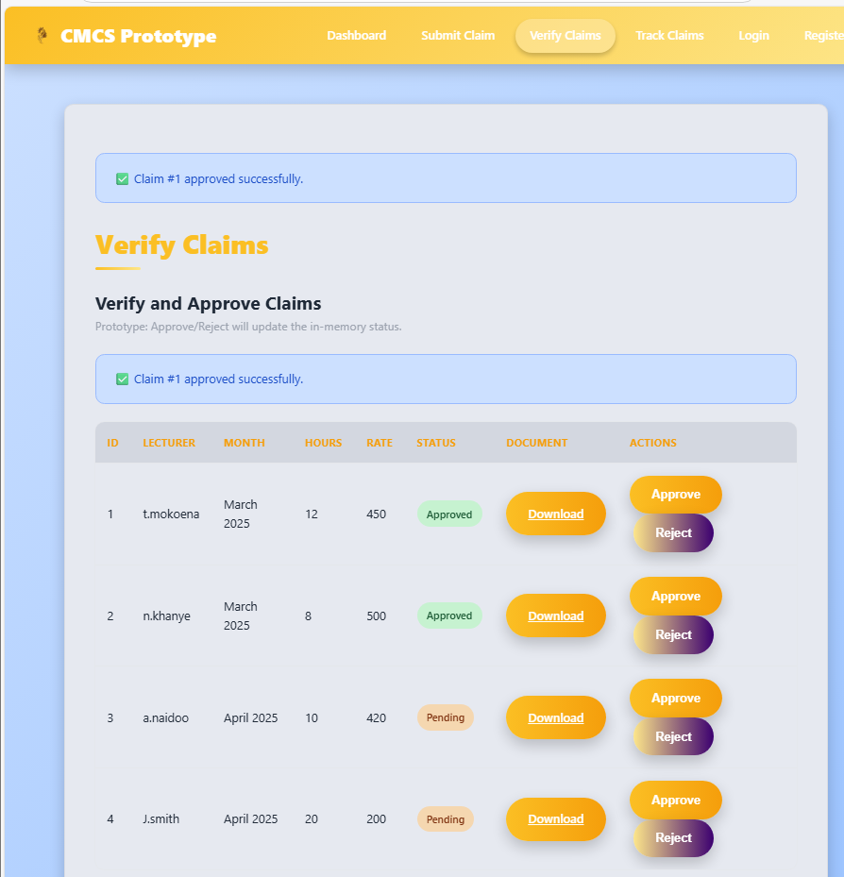

Part 2 also introduces separate verification and approval interfaces for Programme Coordinators and Academic Managers. These views now display pending claims and allow users to approve or reject them directly using clearly marked buttons. When an action is performed, the claim’s status updates in real time from “Pending” to either “Approved” or “Rejected.” This marks a key difference from Part 1, where verification was demonstrated visually only.
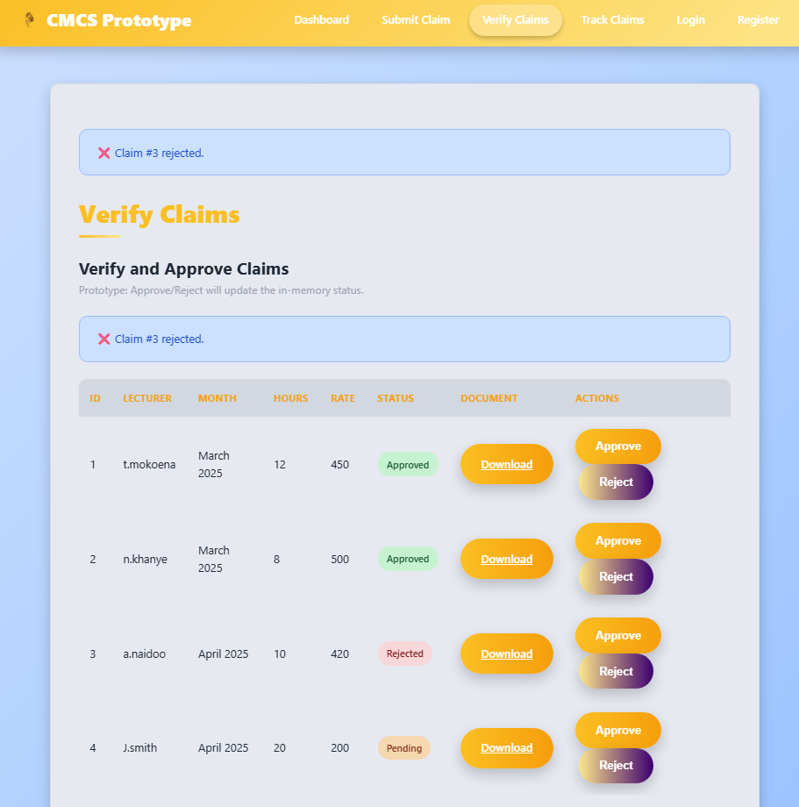

The claim tracking system has likewise been implemented. Lecturers can now view the progress of their submitted claims through a transparent, continuously updated interface. Each claim displays its current status, providing visibility and accountability across all workflow stages.

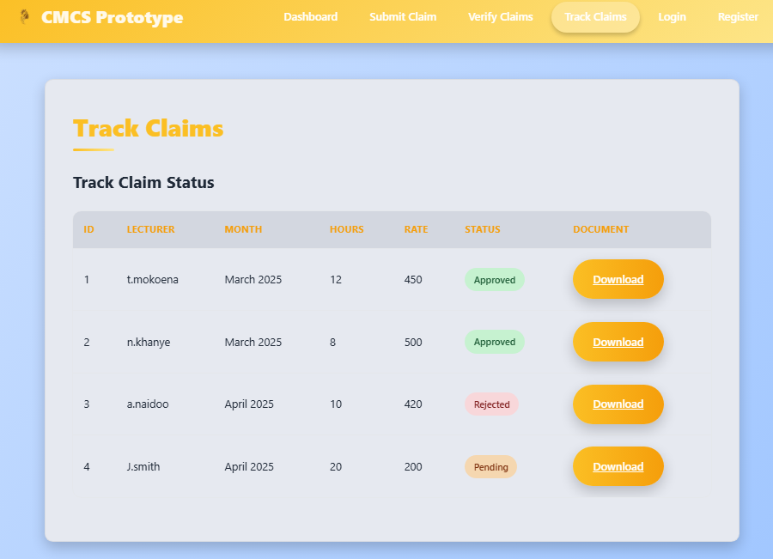

To ensure reliability, Part 2 incorporates exception handling and user feedback mechanisms. Errors such as missing fields, failed uploads, or invalid actions are caught and displayed to users in a clear and professional manner using temporary messages. Furthermore, unit testing was introduced with xUnit and Moq frameworks to verify controller logic, including claim submission, approval, rejection, and tracking.

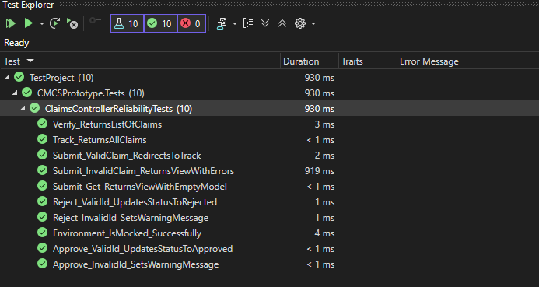

Version control was also enhanced during this phase. Whereas Part 1 involved initial uploads of static design files, Part 2 required continuous integration with at least five meaningful GitHub commits. Each commit documents key implementation milestones such as form validation, file upload integration, approval logic, and test coverage.

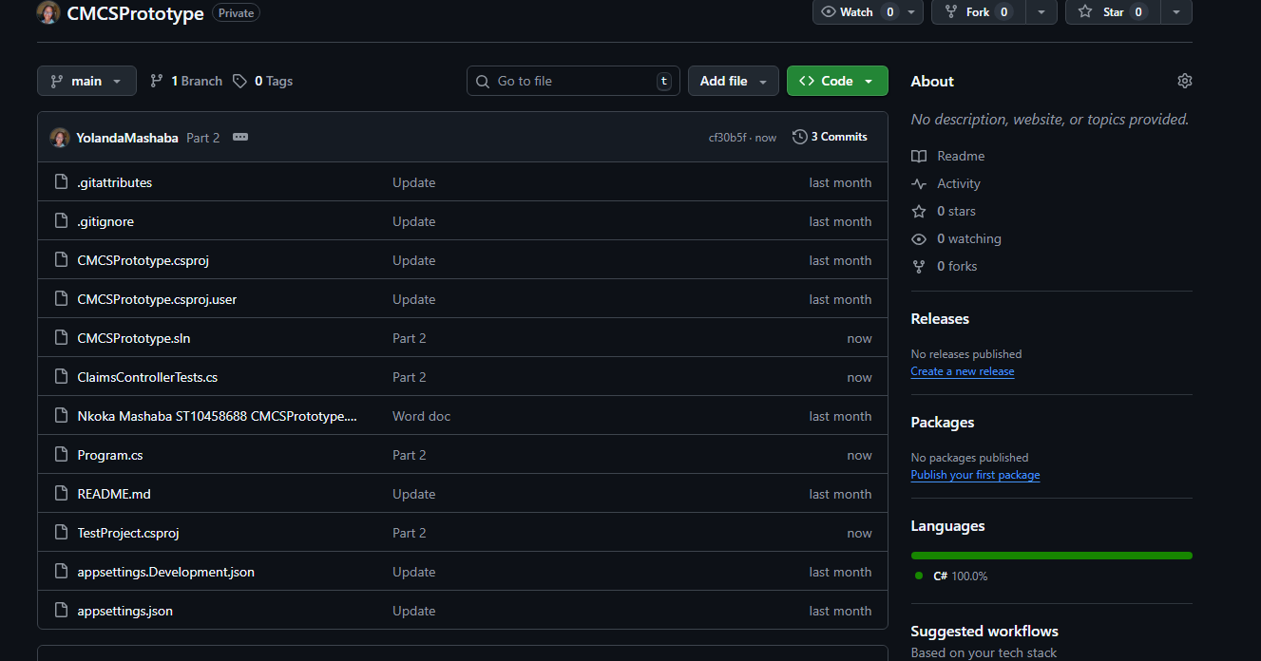
Overall, Part 2 transforms the CMCS from a static prototype into an operational application capable of handling real user interactions. The addition of live functionality, validation, testing, and version control demonstrates technical readiness and practical application of software engineering principles. The system now provides a solid functional baseline for future enhancements such as full database integration, authentication, and deployment in a production environment.

